
QUALITY ALERT

Customer: Seaway Date: March 24, 2024
Die: 15768 Colour: All
Type of Complaint: Customer REJECTED

Q.A # Q.I.R # CUSTOMER NCR #

Description: Customer REJECTE material is OUT of spec causing not fit the punch/router.
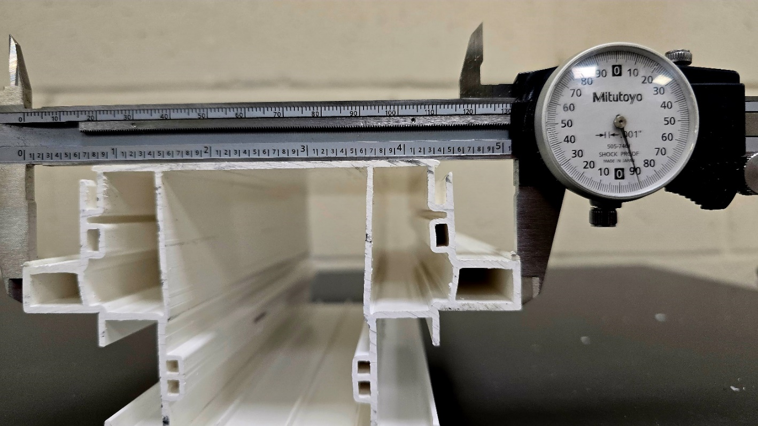

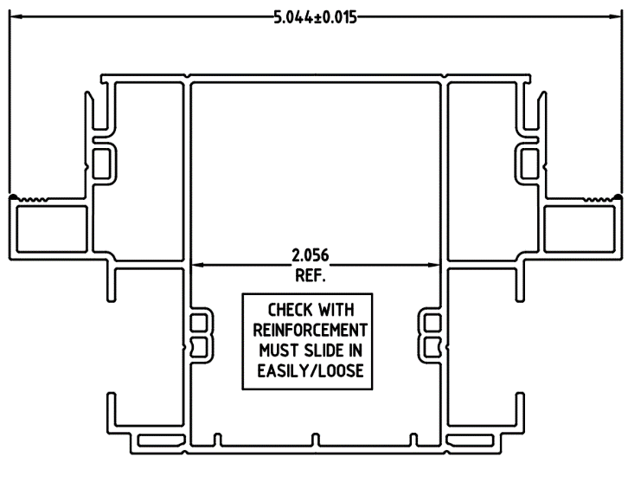

PLEASE MAKE SURE THE DIMENSION IN TOLERANCE

BY SIGNING BELOW, YOU ACKNOWLEDGE THE PROBLEM ABOVE AND AGREE TO MONITOR THIS ISSUE IN FUTURE PRODUCTION RUNS.
DAY SHIFT |  | AFTERNOON SHIFT |  | NIGHT SHIFT
NAME | SIGNATURE | NAME | SIGNATURE | NAME | SIGNATURE

